**Global Online Store Analysis Report**

**1. Overview Dashboard**

**a. Sales Overview**

* Total Sales: $12.64M
* Total revenue: $1.47M
* Total return orders:1079
* Sales Growth:
  + 2013:18%
  + 2014:27%
  + 2015:26%
* Top Selling Products:
  + Phones
  + Copier
  + Chairs
  + Book cases

**Visuals:**

* Card visualization for Total Sales and Sales Growth

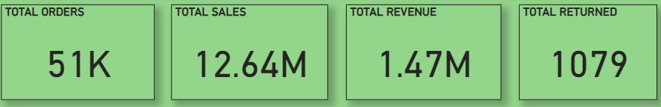

* Table or list visualization for Top Selling Products

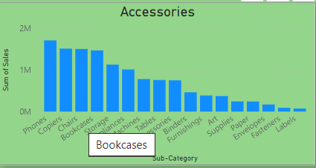

**b. Revenue Breakdown**

* Revenue by Products:
  + Phones: 218.72k or 14.88%
  + Copier :257.58K or 17.52%
  + Chairs :140.40 or 9.55%
* Revenue by Region (Map or Bar Chart)
* Revenue Trend (Line Chart):the trend show that at the start of the year the sales comes down but the passage of time it increase and become high at the end of each year

**Visuals:**

* Pie chart for Revenue by Product Category

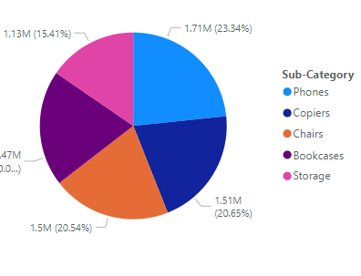

* Map visualization or Bar chart for Revenue by Region

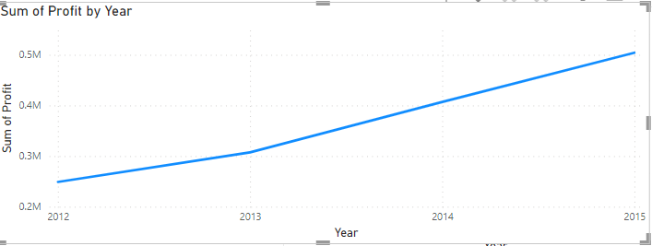

* Line chart for Revenue Trend

**c. Customer Insights**

* Total Customers: 17.62K

**Visuals:**

* Card visualization for Total Customers

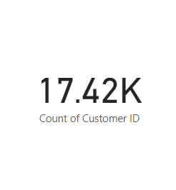

**2. Product Performance Analysis**

**a. Top Products by Sales**

* Phones = 1.71M
* Copiers =1.51M
* Chairs =1.50M
* Bookcases =1.47M
* Storage=1.13M

**Visuals:**

* Bar chart showing sales for top products

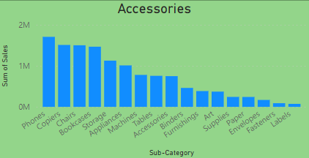

**b. Product Sales Trend**

* Line chart showing sales trend over time for selected products

**Visuals:**

* Line chart showing sales trend over time

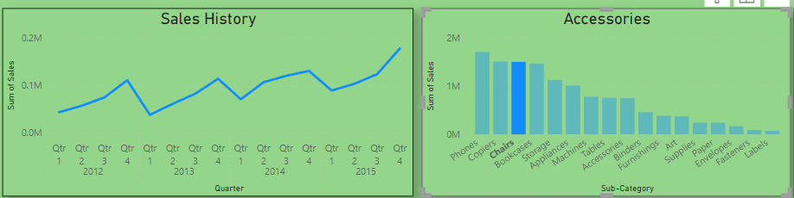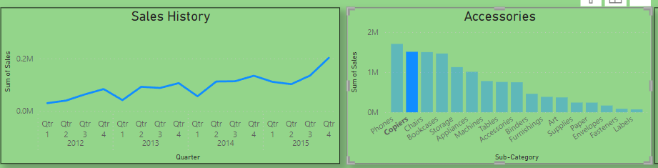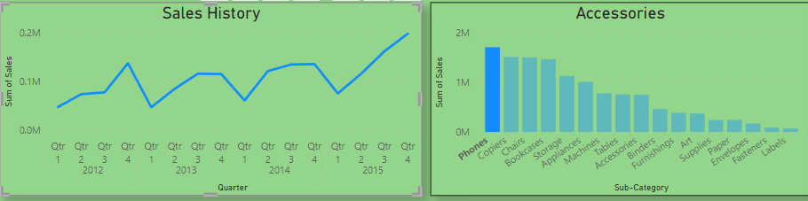

**c. Product Category Analysis**

* Revenue contribution by product category (Stacked Column Chart)
* Phones = 216.72K
* Copiers =258.57K
* Chairs =140.40K
* Bookcases =161.92K
* Storage=108.42K

**Visuals:**

* Stacked column chart showing revenue by product category

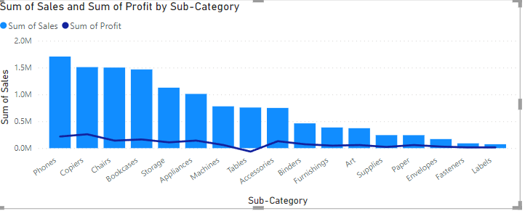

**3. Customer Behavior Analysis**

**a. Customer Purchase Patterns**

* Histogram showing distribution of order frequency

**Visuals:**

* Histogram or column chart showing distribution of order frequency

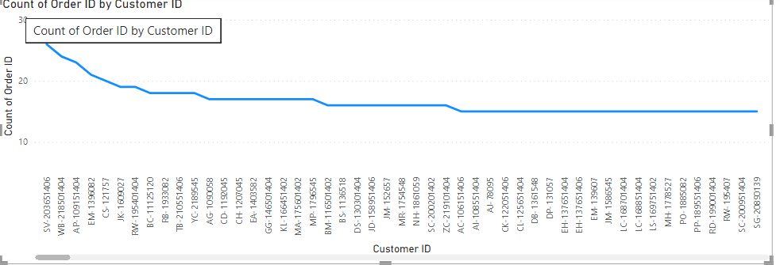

**4. Geographic Analysis**

**a. Sales by Region**

* Map showing sales distribution by region/country

**Visuals:**

* Map visualization showing sales by region/country

**b. Regional Performance**

* Sales growth comparison (Bar chart)

**Visuals:**

* Bar chart showing sales growth comparison by region/country

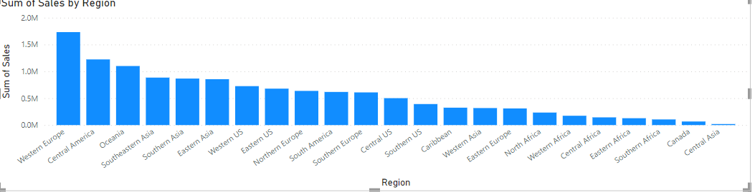

**Tools Used:**

* Power BI Desktop
* Excel (for data preparation)
* SQL Server (for data warehousing)

**Conclusion:**

In conclusion, the sales overview highlights a strong performance with notable growth in total sales and revenue across multiple product categories. The top-selling products, including Phones and Copiers, have consistently driven revenue, reflecting robust market demand. While return orders pose a challenge, the overall sales trend indicates a positive trajectory year-over-year.

To sustain growth, it is crucial to capitalize on product strengths, optimize operational efficiency, and foster deeper customer engagement. By leveraging these insights and implementing targeted strategies, the company can navigate competitive landscapes and achieve sustainable growth in the future.

**Recommendations:**

• Enhance **Product Mix Strategy:**

* Focus on maximizing sales of top-selling products like Phones, Copiers, Chairs, and Bookcases by leveraging their popularity. Consider bundling strategies or targeted marketing campaigns to boost sales further.

• **Optimize Return Order Handling:**

* Given the number of return orders, implement strategies to reduce returns by improving product descriptions, customer support, and quality assurance processes.

• **Regional Expansion Opportunities:**

* Identify regions with high growth potential based on sales analysis. Allocate resources towards expanding market presence in these regions to capitalize on emerging opportunities.

• **Customer Engagement and Loyalty Programs:**

* Develop personalized marketing strategies and loyalty programs to retain existing customers and attract new ones. Utilize customer insights to tailor offerings and improve overall customer satisfaction.

• **Continuous Sales Monitoring and Forecasting:**

* Implement regular sales forecasting and monitoring mechanisms to adapt quickly to changing market conditions and ensure sustainable growth.